**Target List Hydra**

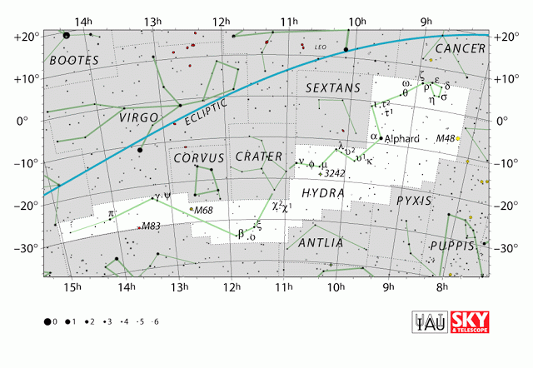

|  |  |  |
| --- | --- | --- |
| Object | Description | Magnitude |
| M83 | Galaxy | 7.6 |
| M68 | Globular Cluster | 8.4 |
| NGC 3242 | Ghost of Saturn Planetary Nebula | 9 |
| M48 | Open Cluster | 5.8 |
| Epsilon Hydra | Variable Double Star Separation 2.9” | 3.4/4.9 |
| Alphard | Binary Star | 2.0 |

|  |  |  |  |  |
| --- | --- | --- | --- | --- |
| Object | Description | Magnitude | Date Observed | Notes |
| M83 | Galaxy | 7.6 |  |  |
| M68 | Globular Cluster | 8.4 |  |  |
| NGC 3242 | Ghost of Saturn Planetary Nebula | 9 |  |  |
| M48 | Open Cluster | 5.8 |  |  |
| Epsilon Hydra | Variable Double Star Separation 2.9” | 3.4/4.9 |  |  |
| Alphard | Binary Star | 2.0 |  |  |

